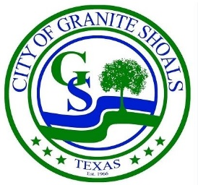
City Manager Report
March 2025

I am pleased to present the City Manager's Report for the month of March 2025. In addition to the departmental reports regarding finance, fire, streets and parks, police and utilities, this report provides an overview of key activities, committees, projects, events, and updates Citywide.
Committees
Planning and Zoning Committee: The Planning and Zoning Commission will have their next meeting on April 1st at 6:00 PM.
Wildlife Committee: The Wildlife Committee had an engaging meeting on March 3rd. The next meeting will be held April 7th at 6:00 PM in the City Council Chambers.
Board of Adjustments: The Board of Adjustments (BOA) met on February 26, 2025 at 6:00 PM. No meetings have been scheduled yet for March.
Airport Committee: The Airport committee met on March 6th. The next meeting will be held on April 3rd at 3:00 PM.
Parks Committee: The Parks Committee met on March 6th. The next meeting is scheduled for April 3rd at 6:00 PM.
Administration
Staff Certification and Recognition
- One of our Police trainees (currently in the Police academy) recently received recognition for her lifesaving efforts toward another recruit at the last Council meeting.
- Texas Municipal Clerks Certification – Dawn has completed 3 of her 4 tests toward her Municipal Clerk designation.
- Our Fire Chief is working toward additional Fire accreditation for his command staff.
- We are now recognized as a medical First Responder Organization with the state of Texas.
- Our Chief of Police received a grant to attend FBI Leadership training, and this week was in the second of three courses to obtain the FBI LEEDA Trilogy certificate.
- Our City Manager was recently appointed to the board of the Texas City Management Association (TCMA).

Building Department
Online permit payments: The City is excited to announce the rollout of online permit payments, making the permitting process more convenient and efficient for residents and businesses. This new feature allows users to submit payments securely online, reducing the need for in-person visits and streamlining transactions. The system is now online and operational!!
Fire

A Burn Ban for the City of Granite Shoals was officially implemented on March 2, 2025, due to ongoing dry conditions and increased fire risk. Residents are urged to refrain from all outdoor burning until further notice. Please monitor official city channels for updates.
An insightful and informative article about urban wildfire disasters like recently occurred in Los Angeles. More than 1,100 communities over 32 states share similarities with places recently devastated by urban wildfires. More than half of them are not in the West, and several local areas on the map (in the attached link) include cities in the Highland Lakes region. https://headwaterseconomics.org/wildfire/more-than-1100-communities-urban-wildfire-risk/
Parks and Streets

The Streets team recently solicited bids for crack filling and repair on the three major thoroughfares funded by the 2018 street bond: Phillips Ranch, Valley View, and Prairie Creek. These repairs are part of regular maintenance efforts and are essential to preserving and extending the lifespan of the City’s major thoroughfares. Keeping these roads in good condition ensures safer travel for residents and helps protect the City’s long-term infrastructure investments. LoneStar paving was the lowest qualified bidder and will be performing crack filling and repair of the three thoroughfares which we have remaining bond funds for (Phillips Ranch, Valley View and Prairie Creek.) These projects will begin on March 24.

Utilities
The Utility department went out to bid for a line upgrade project at N Shorewood/W Greencastle to address significantly undersized lines that have created pressure issues and a myriad of breaks. The contract was awarded to the lowest qualified bidder and work is expected to commence shortly.
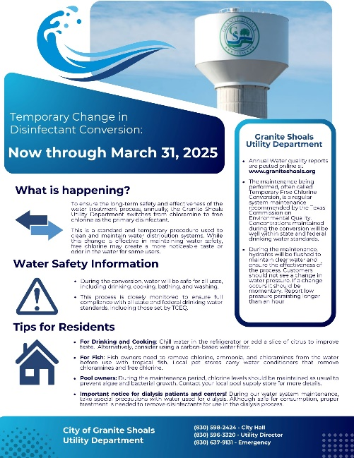
Throughout the month of March, the Utility department has implemented a temporary disinfectant conversion to free chlorine. This measure is done in coordination with TCEQ and helps maintain water quality and system integrity. This temporary conversion is standard practice and helps maintain the highest level of water quality for the Granite Shoals community.
More information can be found at: https://www.tceq.texas.gov/.../temporary-free-chlorine...
City of Granite Shoals Annual Water quality reports are posted online at: https://www.graniteshoals.org/.../utilities-public-notices
GIS update – The City’s infrastructure maps are currently undergoing migration to a new, modernized mapping and data management system. This updated platform will provide improved access to critical infrastructure data, enhance accuracy, and support better decision-making across departments. Once the migration is complete, staff will undergo comprehensive training to ensure effective use of the system. Full implementation will integrate this platform into daily operations, streamlining workflows, improving coordination, and ultimately supporting long-term planning, maintenance, and capital improvement efforts throughout the City.
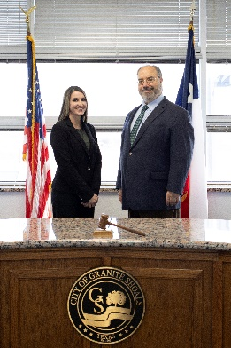
Court
On February 28, 2025, Judge Reilly officially swore in Victoria Lockhart as the new Court Clerk for the City of Granite Shoals during a ceremony held in the Council Chambers.
Former Court Clerk Selena Whyte, who now serves as a Records Clerk with the Granite Shoals Police Department, has graciously agreed to assist with training Ms. Lockhart. The two recently visited Marble Falls Communications for a cross-training session to support a smooth transition.
Hill Country Humane Society The Trap-Neuter-Release (TNR) clinic has been rescheduled to March 28, 2025. Thanks to a generous grant from Hill Country Cats, approximately 30 spots in the clinic have been reserved for Granite Shoals cats.
We are grateful for the ongoing partnership with the Hill Country Humane Society, which continues to play a vital role in securing additional funding and veterinary support to expand TNR efforts and host more clinics in the future.
Event Recap
City staff have been working hard in preparation for an exciting lineup of events over the next few months. Below is a summary of some of the upcoming City events:
We look forward to bringing the community together and hope to see you there! Stay tuned for more details, and feel free to reach out if you have any questions.

March
- 22 – Granite Fest and Car Show granitefest.com
- 29 - MFISD/PEC Touch a Truck
- 29 – Wildlife Town Hall - Fire Station 10 AM
April
- 5 – Citywide Clean Up
- 12 – Airport Kite Day 10:00 AM -1:00 PM
- 19 – Easter Eggstravaganza at Quarry Park
- 25-26 - High School BBQ State Competition at Quarry Park
May
- 2 -3 Howdy Roo at Quarry Park
- 3 - Election day (Community Center closed 4/19-5/4)
June
- 20-21 – Battle of the Badges BBQ at Quarry Park

