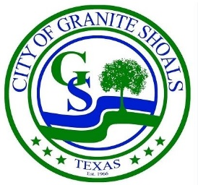
City Manager Report
April 2025

I am pleased to present the City Manager's Report for the month of April 2025. In addition to the departmental reports regarding finance, fire, streets and parks, police and utilities, this report provides an overview of key activities, committees, projects, events, and updates Citywide.
Committees
Planning and Zoning Committee: The Planning and Zoning Commission met on April 1st at 6:00 PM. Their next meeting will be held on May 6th.
Wildlife Committee: The Wildlife Committee had an engaging meeting on April 7th. The next meeting will be held May 5th at 6:00 PM in the City Council Chambers.
The Wildlife Advisory Committee also hosted a Town Hall Meeting on March 29, 2025, to share information on the City’s wildlife history and harvesting program. The program operates under the Managed Lands Deer Permit (MLDP) and is guided by TPWD biologists and game wardens. For more information, visit the City Website for Wildlife Advisory Committee updates at: https://www.graniteshoals.org/home/showpublisheddocument/2852
Board of Adjustments: The Board of Adjustments (BOA) did not meet in April. No meetings have been scheduled yet for May.
Airport Committee: The Airport committee met on April 9th. The next meeting will be held on May 1st at 3:00 PM.
Parks Committee: The Parks Committee met on April 3rd. The next meeting is scheduled for May 1st at 6:00 PM.

Administration
City Receives “We Hire Vets” Recognition
The City of Granite Shoals has been officially recognized by the Texas Workforce Commission and Texas Veterans Commission with the “We Hire Vets” designation. This honor is awarded to employers whose workforce includes at least 10% military veterans. Granite Shoals exceeds that benchmark, with 18% of its workforce made up of veterans.
Website Transition Underway
The City of Granite Shoals has launched a new website platform for hosting agendas and public announcements as part of a larger website upgrade expected in May or June 2025. While the current site will continue to host meetings and agendas during the transition, the new platform will offer a more streamlined and user-friendly experience—including online payments, form submissions, facility rentals, and notification alerts, all accessible from digital devices.
Comprehensive Plan Update Coming Soon
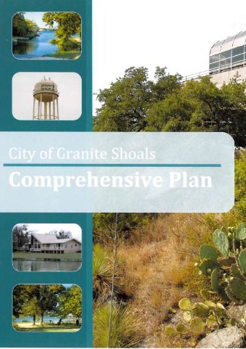
The City of Granite Shoals will soon begin updating its Comprehensive Plan, which was last drafted in 2010. This important document provides a unified vision for the city’s future, guides land use and zoning decisions, directs infrastructure and capital improvement planning, supports economic development strategies, improves eligibility for grants and funding, promotes coordination across city departments and leadership, and encourages public engagement by involving the community in shaping long-term goals. Comprehensive Plans are typically updated every 5 to 10 years to ensure they reflect current growth trends, infrastructure needs, and community priorities. Public input will play a key role, with several opportunities for residents to share feedback both online and in person—ensuring everyone has a voice in shaping the future of Granite Shoals.
Requests for Qualifications “RFQ” & Engineering Services
Solid Waste RFQ
- The City will soon solicit qualifications for Solid Waste providers as the current agreement with Waste Management is set to expire at the end of the year.
Comprehensive Plan RFQ
- The City will also issue an RFQ to identify qualified vendors to assist with the upcoming Comprehensive Plan update.
Engineering Services RFQ
- The City received four responses to its recent RFQ for engineering services. After interviewing the top two firms and completing reference checks, staff will recommend hiring both. One is a larger firm that brings extensive experience in streets, water, wastewater, drainage assessments, and related grant funding, while the other is a more boutique firm that offers personalized service and expedited reviews for development projects. Engaging both firms allows the City to leverage their respective strengths and access necessary engineering expertise to support its development and infrastructure planning needs effectively.
Police
Police Boat Equipment
The Granite Shoals Police Department is pleased to announce a significant enhancement to its search and recovery capabilities thanks to a generous donation of two advanced sonar graph units for the Police boat. These graphs are specialized tools used for underwater detection, playing a critical role in search and recovery operations on the lake.
Both units have now been successfully installed and are fully operational, providing officers with improved accuracy and efficiency when responding to water-related incidents. The department is grateful for the support that makes these upgrades possible and remains committed to ensuring public safety both on land and on the water.
Police Department Secures Equipment Through DOD Surplus Program
The Granite Shoals Police Department recently acquired several high-value items through the Law Enforcement Support Office (LESO) DOD Surplus Program, which provides military surplus equipment to law enforcement agencies at little to no cost.
This initiative offers significant savings for the City and demonstrates the department’s resourcefulness in securing tools and technology that enhance operations.

Fire
Burn Ban Remains in Effect
A Burn Ban for the City of Granite Shoals was officially implemented on March 2, 2025 and remains in effect, due to ongoing dry conditions and increased fire risk. Residents are urged to refrain from all outdoor burning until further notice. Please monitor official city channels for updates.

Celebration of New Fire Tender with Push-In Ceremony
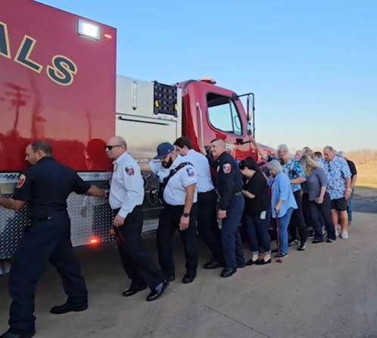
The Granite Shoals Fire Department recently welcomed its new Tender Truck with a traditional Push-In Ceremony at the Fire Station. This time-honored fire service tradition brought together firefighters and community members to symbolically push the new apparatus into service.
The truck, acquired at no cost to the City thanks to a $246,000 U.S. Forest Service grant and a $103,000 contribution from the Granite Shoals Fire Auxiliary, marks a significant upgrade in the City’s firefighting capabilities.
Finance
FY 2026 Budget
Departmental budget discussions for the FY 26 budget are underway, and we will be scheduling budget workshops with the Council in the coming weeks and months.
FY 2024 Audit
The City’s annual audit report for FY 2024 is expected to be delivered in May 2025.
Credit Card Machines
- New credit card machines with tap-to-pay functionality have been installed at the City’s service counters.
- An additional machine was placed upstairs near the Council chambers for use by Municipal Court staff when processing payments.

Parks and Streets
Street Improvement Update
LoneStar Paving has completed bond-funded repairs on Phillips Ranch, Valley View, and Prairie Creek. Staff are seeking cost estimates for potential trail connections and/or ribbon curb enhancements along each of these three thoroughfares to enhance pedestrian safety and extend the life of the roadways.
Parks & Facilities Improvement Update
Our Parks and Streets crews have started preparing the future site of the amphitheater by placing fill dirt to help shape the area. The City will be gathering cost estimates soon to move forward with design and development planning.
Staff are also seeking quotes for several other community enhancements, including:
- Exterior painting and maintenance of the Community Center and pavilion at Veterans Park.
- Pickleball court restriping to expand recreation options.
These efforts reflect our continued commitment to maintaining and enhancing public spaces throughout Granite Shoals. Stay tuned for more updates as projects progress!
Utilities
Valley View Water Tower Repairs
- Repairs to the Valley View water tower will begin April 21st.
- The tower will be offline for 3–4 days, with the Bluebriar system supplying water service to the City during that time.
Water Transmission Line Upgrade
The City’s next water transmission line upgrade is scheduled to begin in mid-April and will affect residents and property owners along North Shorewood, Castle Way, the 200 block of West Greencastle, and Castlehigh. This project involves replacing 2,500 linear feet of aging 1½-inch main line with a new 6-inch water main, along with the installation of five new fire hydrants to enhance fire protection in the area.
This is one of several major improvements funded through the 2019 Water Infrastructure Bond, which has already supported the construction of the new elevated storage tank on Bluebriar, facility upgrades at the City’s Water Treatment Plant, and, more recently, the replacement of 1,600 linear feet of water main (with new fire hydrants) along the south side of Kingswood Drive. Approximately $1.6 million remains in bond funds for continued distribution main replacement.
Notification letters have been sent to all affected property owners. Residents can expect to see increased activity from City crews and Qro-Mex Utility Construction teams in the area during this time.

GIS update
The City has transitioned its mapping data to a new GIS platform. Staff will now begin updating water line locations and training designated employees on system use. Once fully implemented, the platform will enhance accuracy, improve access to infrastructure data, and streamline workflows—supporting better coordination, long-term planning, and maintenance across City departments.
City of Granite Shoals – April and May 2025 Events & Meetings
We look forward to bringing the community together and hope to see you at these upcoming events. Stay tuned for more details, and feel free to reach out if you have any questions.

April

- 5 – Citywide Clean up
- 7 – Wildlife Town Hall
- 8 – City Council meeting
- 9 – Airport Advisory committee meeting
- 12 – Airport Kite Day event 10-1pm
- 18 – City offices closed in observance of Good Friday
- 19 – Easter Eggstravaganza at Quarry Park
- 19 – 5/4 – Elections (Community Center Closed for public use/event rental)
- 22 – City Council meeting
- 25-26 - High School BBQ State Competition at Quarry Park https://www.youtube.com/watch?v=SWRkjdnjdB0
- 26 - “Wags to Riches” Hill Country Humane Society Fundraiser - 5:00 pm - 1601 S Water St, Burnet, TX 78611. Tickets can be found at: https://e.givesmart.com/events/unq/

May

- 1 – Airport & Parks Advisory Committee meetings
- 2 -3 Howdy Roo at Quarry Park
- 3 - Election day
- 4 – International Firefighter day
- 5 – Wildlife committee Meeting
- 6 – Planning & Zoning Meeting
- 10 – Media Bass Tournament
- 11-17 National Police Week
- 13 – City Council Meeting
- 15 – National Police Officer Memorial Day
- 17 – Media Bass Tournament
- 19-25 – National Public Works Week
- 26 – Memorial Day
- 31 – Pickleball Event

